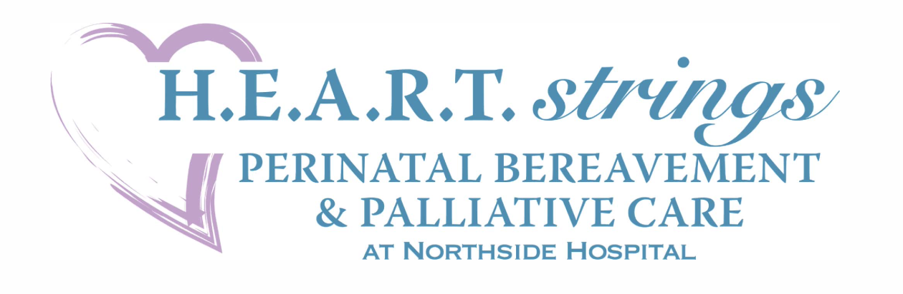

H.E.A.R.T.strings Perinatal Bereavement Office Year-end Report 2023

Direct Patient Support:
- Served over 370 families with perinatal losses in L&D and SCN on all four campuses.
- In addition to those numbers, we provided support to patients in the ED and Surgical Services, as well as Women’s Surgical Unit.
- We also served families from around the country who joined our online support groups, called or emailed the office for support, or asked for a Reagan Marie bear to be sent to them. Our online support groups served over 325 families this past year. This number is a record for our office!
- We hosted a virtual monthly support group, Caring & Coping, which served 285 families through the support group format and monthly mailings on handling grief.
- In October 2023, approximately 1000 people walked in various areas for our 19th annual Atlanta Walk to Remember event, an event that is funded through sponsorships and donations. We raised over $14,000 in sponsorships, increased awareness for Pregnancy & Infant Loss Awareness Day, mailed out 250 remembrance boxes and provided Kona Ice for staff on several campuses.
- Our H.E.A.R.T.strings Companions, a peer-to-peer mentoring program which trains parents to be matched with the newly bereaved for one-to-one support, remains active with new mentors added and new families served.
- We continued to partner with various organizations, including the Smocking Guild of Atlanta, Tiny Stitches, and the Northside Auxiliary, to provide donated gowns and keepsake items for families.
- Our key patient resource, the “Survival Guide: Information & Guidance For Your Loss”, a Gold Award Winner in the Patient Handbook Category of the 35th Annual Healthcare Advertising Awards, was revised and continued to serve as a benchmark for perinatal bereavement resources.
- Twelve families received perinatal palliative care planning through the H.E.A.R.T.strings Palliative Care Program. We worked with Interpretation Services to create a Spanish version of our resource “The H.E.A.R.T.strings Consult”, so that we can better serve our patient population.
- Our Rainbow P.A.L.S. Program provided it’s new “Rainbow Baby Journal” for parents experiencing a pregnancy after loss and provided over 100 rainbow baby packages.
- We continued a partnership with Mothers’ First to train staff and develop a protocol that now enables us to provide private childbirth education for palliative care families.
- We partnered with Customized Communications to format and offer a bereavement app through the Yomingo platform, which will complement our Survival Guide and serve as a valuable resource for our families.
Staff Training & Support:
- We provided hospital-based bereavement and palliative care training to staff members from 5 different departments across 4 campuses, including hosting several workshops for staff and an NPIC webinar.
- Added over 25 staff members to the Good Grief Club, a program that acknowledges excellent and compassionate perinatal bereavement care.
- Our Butterfly Garden on the NSA campus continues to serve as an area for staff respite.

Thank you for helping us to achieve these goals!
Melissa, Brigette, Leah, Christina, Tina, Eve & Tonya

